Practical 6: Stack Implementation using Array and Linked List, with Expression Processing
Practical Aim
To implement stack using array and linked list, and apply stack-based logic to expression conversion, evaluation, and bracket validation problems.
Problem 1
A cafeteria stacks clean trays on a fixed-size counter. New trays are always placed on top, and customers always take from the top. The counter can hold at most n trays at a time — if it is full, no more trays can be added, and if it is empty, no tray can be taken. Given a sequence of place and take operations, implement this fixed-capacity tray stack and print the current top tray after each operation. Report an error if a place or take operation cannot be performed.
Describe how your solution tracks whether the stack is full or empty. What are the exact conditions you check before a push and before a pop, and what does your program do when those conditions fail?
SOLUTION:
https://github.com/prathameshpandir-dev/DSA-Batch-B-SHP/tree/main/practical-6
OUTPUT:

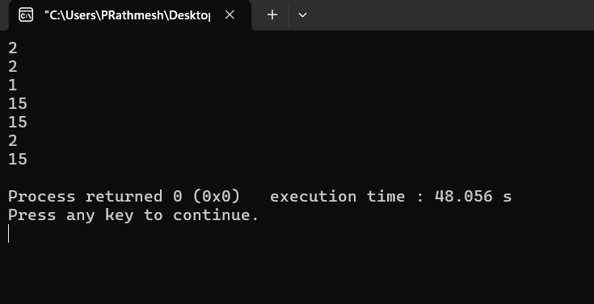

PROBLEM FACED:
The main difficulty was correctly checking overflow before placing a tray and underflow before taking one. The top position must also be updated after every operation.
CONCLUSION:
The fixed-size stack was successfully implemented with push and pop operations. Overflow and underflow conditions are checked before changing the stack.
Problem 2
A web browser keeps track of pages visited so that the back button always returns to the most recently visited page. Unlike a fixed counter, the browser has no hard limit on how many pages it can remember — it grows as the user visits more pages and shrinks as they press back. Given a sequence of visit and back operations, implement this unlimited page history and print the current page after each operation.
Describe how your solution differs from Problem 1 in how it handles memory. What happens in your solution when the user presses back on the very first page with no history left?
SOLUTION:
https://github.com/prathameshpandir-dev/DSA-Batch-B-SHP/tree/main/practical-6

OUTPUT:

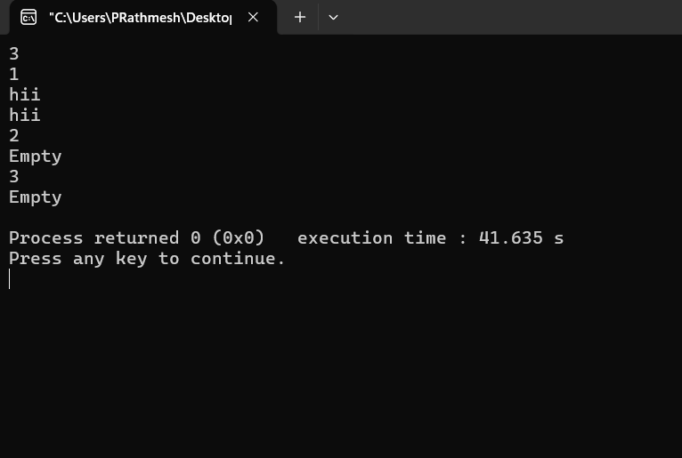

PROBLEM FACED:
The main difficulty was handling a dynamically growing stack and making sure the back operation does not remove anything when there is no previous page.
CONCLUSION:
The linked-list stack successfully provided dynamic browser history. It does not have the fixed capacity of the array stack and safely handles an empty history.
Problem 3
A calculator application receives arithmetic expressions typed by users in the usual way — numbers and operators written in between, with brackets to control priority. Internally the calculator needs to convert each expression into a form where operators appear after their operands. Given an infix expression, convert it to the equivalent postfix form and print the result.
Describe the role the stack plays in your conversion. What does your solution do when it encounters a closing bracket, and what happens to the operators that were waiting on the stack at that point?
SOLUTION:
https://github.com/prathameshpandir-dev/DSA-Batch-B-SHP/tree/main/practical-6

OUTPUT:

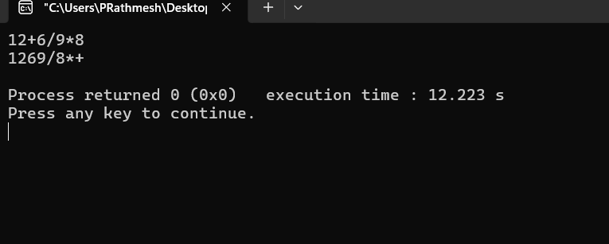

PROBLEM FACED:
The main difficulty was applying operator precedence correctly and handling brackets. Operators are kept on the stack until their correct position in the postfix expression is reached.
CONCLUSION:
The infix-to-postfix conversion was successfully implemented using a stack. Operators are arranged according to precedence and brackets are removed from the final postfix expression.
Key questions
1. Problem 1
Answer: A circular array can reuse freed positions by moving the rear back to the beginning using modulo indexing. The front and rear pointers are updated with circular movement, and the queue is full when the next rear position would reach the front.
2. Problem 2
Answer: Yes, a linked-list stack can still run out of space. Its actual limit is the available memory of the computer. The code does not specify a fixed capacity because nodes are created dynamically.
3. Problem 3
Answer: If all operators were treated as having equal precedence, expressions such as multiplication and addition could be placed in the wrong order. The postfix expression would then represent a different calculation from the original infix expression.
Overall Conclusion
The practical successfully implemented stacks using both arrays and linked lists and applied stack operations to expression conversion. The difference between fixed and dynamic stack capacity and the importance of operator precedence were understood.

